Writers Attend White House Summit
By Brigid O’Farrell
The White House Summit on Worker Voice on October 7 brought together workers, including writers, labor leaders, business owners, government officials, and advocates.
President Obama told those gathered in the East Room: “We should be making it easier, not harder, for folks to join a union.” Yet he cautioned that those who would organize have to take into consideration pushback from corporations, “You can’t just keep on doing the same things, thinking you’re going to get a different outcome.”
He challenged attendees, including fast food workers, trades people, auto workers, adjunct faculty, nurses, child care workers, and writers—along with those watching via live stream across the country—to develop innovative strategies and models that include alternative organizing efforts.
Hamilton Nolan, the Gawker writer who spoke at the August NWU Delegate Assembly about his publication’s successful organizing efforts, cautioned: “No savior will be coming down from Washington to win the class war. So we have to win it ourselves.”
The daylong session closed with the President joining a Town Hall Meeting moderated by Michelle Miller of coworker.org, who asked the President questions that had been sent in on-line; she also engaged the audience for some of the answers.
One of the last questions of the day came from Sunday Steinkirchner, a writer and small business owner in New York, who wrote: “What will you do to help freelancers and small business owners get paid for their work?” The President said he didn’t have a good answer to that, and sought to crowd source one from those assembled.
Sara Horowitz, founder of the Freelancers’ Union with 300,000 members nationwide, took up the challenge and pointed out out that 53 million Americans are independent workers, which is roughly a third of the US workforce. She pointed out that upwards of 70 percent of them don’t get paid for their work at some point in their careers.
“Help is on the way” through the union new awareness campaign “#FreelanceIsn’tFree,” she said, adding that New York City is developing legislation to require that companies have written contracts for freelance workers, propose shorter wait times for payment, and include harsh penalties for violations . Three months is too long to wait for payment and nonpayment is unacceptable, she asserted. She suggested that the legislation could set a precedent for the rest of the country.
The Freelancers Union is coordinating with other unions, which may create an opportunity for the NWU to collaborate with them. Check out #StartTheConvo.

Brigid O’Farrell is a member of the NoCal chapter of NWU/IFJ. She had an IFJ press access to the summit.

Six Possible Photos
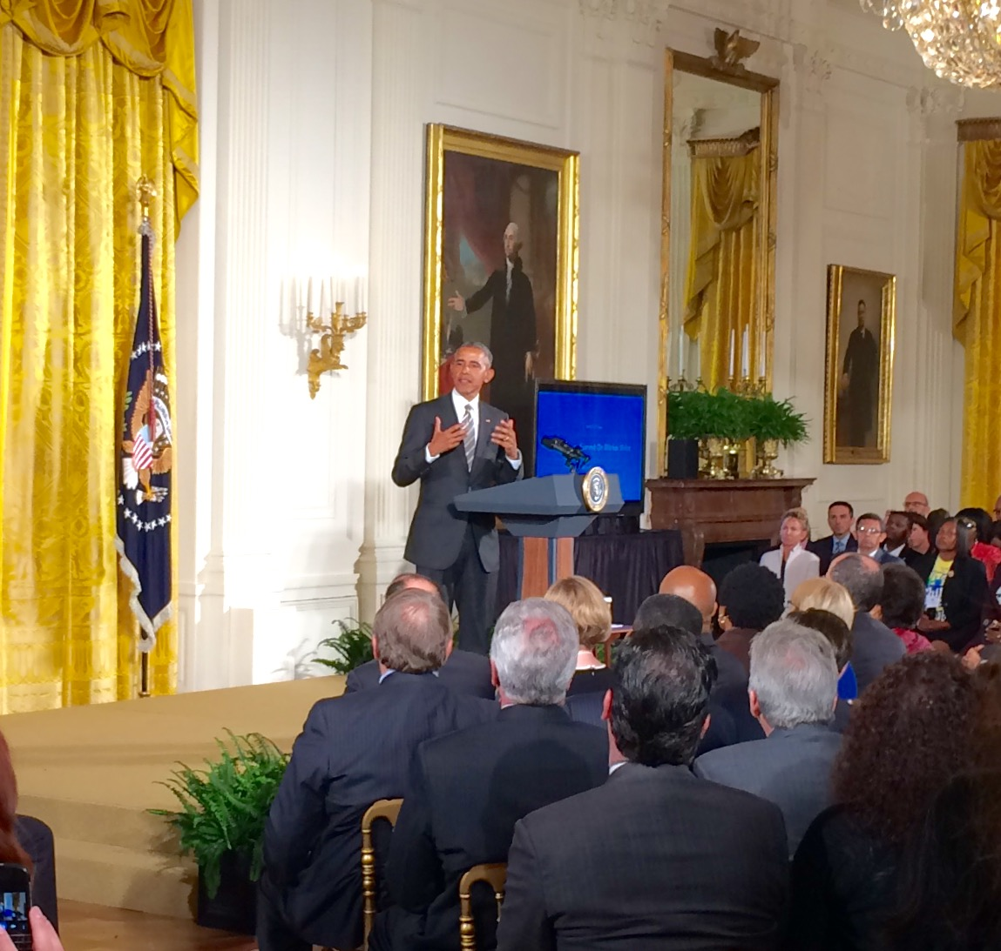
In the East Room

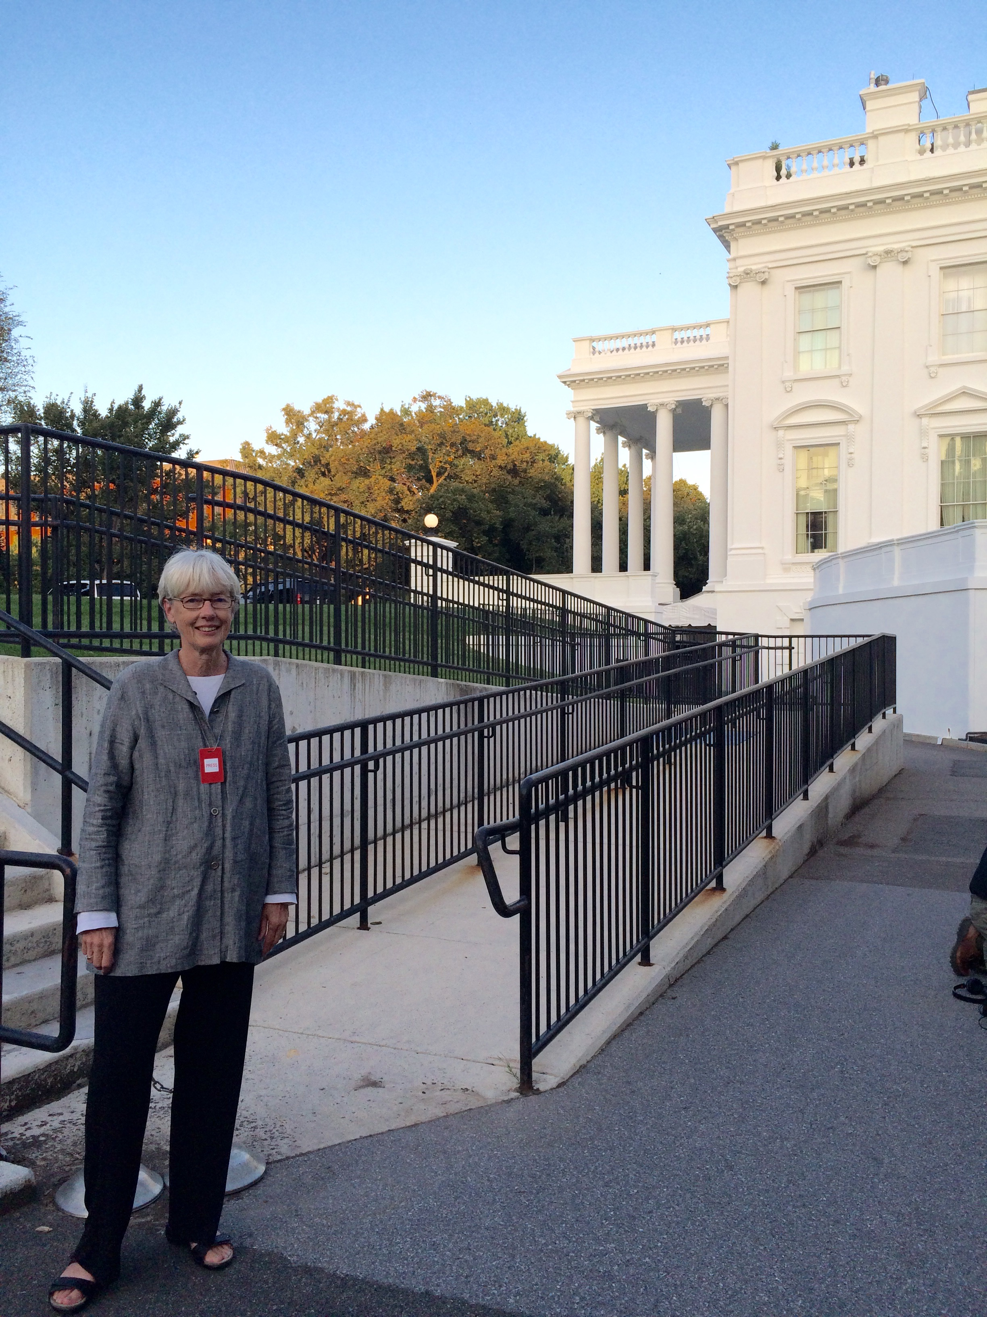
Outside the White House Press Office

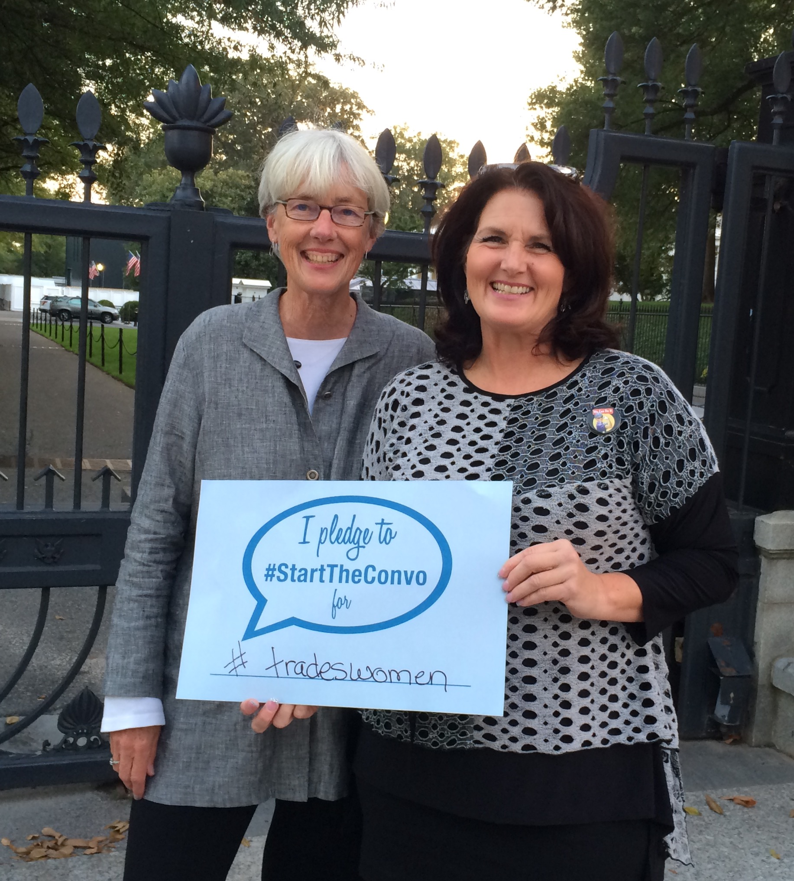
With White House Guest, Kim Brinkman,
Sprinkler Fitters, UA, Local 417, MN
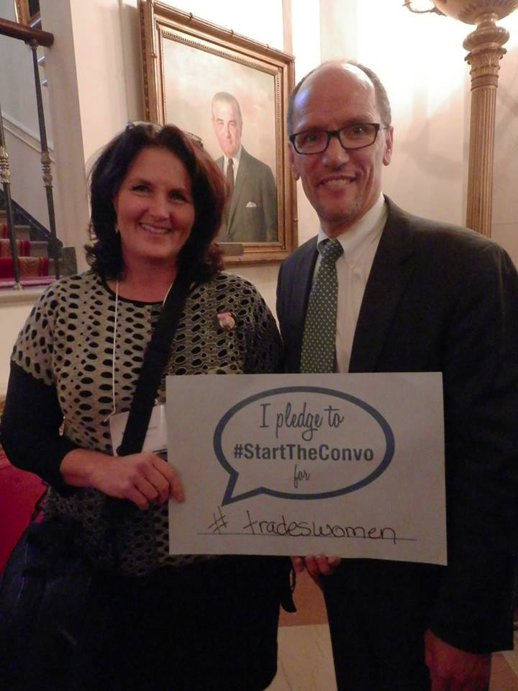
With Secretary of Labor Perez

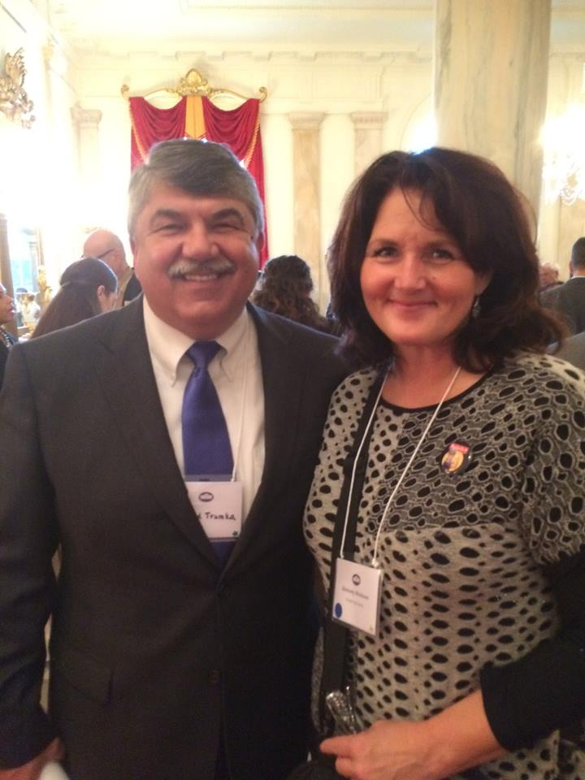
With Richard Trumka, President, AFL-CIO

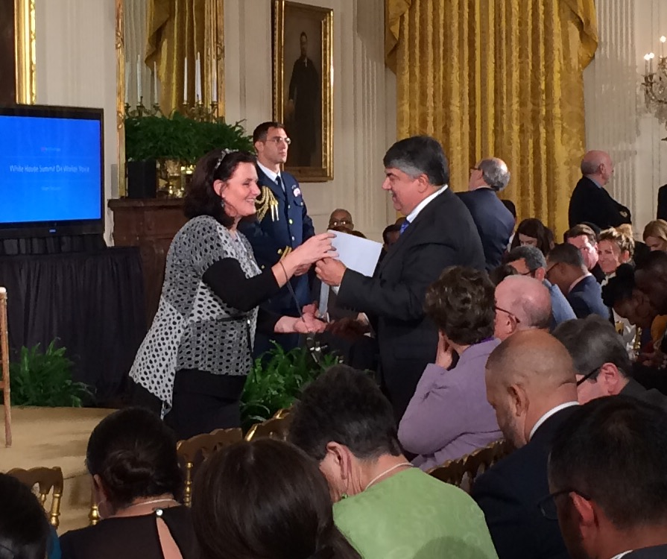
With Trumka

